Example of evidence to be handed in with Application Form
Universal Credit – if households receive any element of this ensure this is the primary evidence submitted. | Please download the last three consecutive monthly statements that clearly show the claimant's name, address, and the sections detailing entitlements and deductions. All Pages, see below example 1.  Example 1  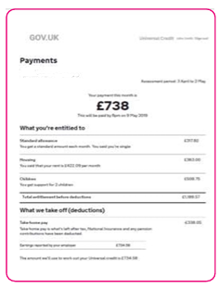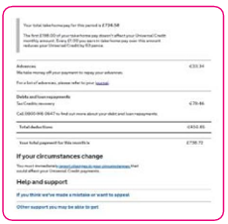  To do this  - Log into your UC account and go to Payment screen  - Select the month you wish to view  - Click – Print This Statement  - Once you click Print This Statement, a window will pop up  - Use the Download Buttonand select a location for the download to be sent  The statement will then save as a PDF document which you can then attach to an email  If you cannot navigate this please take screen shots and save as photos which you can then attach to an email  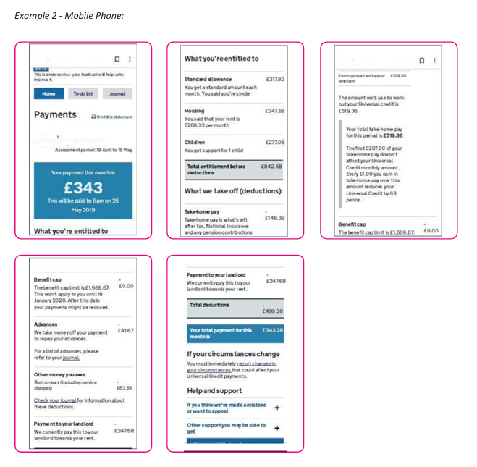

If the household does not receive any Universal Credit the following evidence will be accepted.
Submit all of the following evidence which applies.
Job Seekers Allowance |  | Latest Award letter, no more 12 months old. All Pages
Income related Employment and Support Allowance |  | Latest Award letter, no more 12 months old. All Pages
Support under part VI of the immigration and Asylum Act 1999 |  | Evidence of provided support
Guaranteed element of Pension Credit |  | Latest award letter, no more than 12 months old All Pages
Salary - Employed | Provide a copy of your P60 dated April 26 or last consecutive 3 months' pay slips.
Self-Employed | Latest documentation from Accountant or Self -Assessment showing gross earnings
Pension | Provide the latest pension statement/P60.

