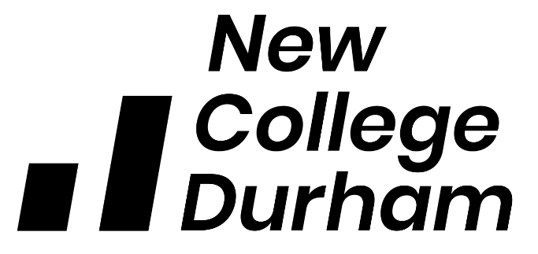

EMPLOYER COMMUNICATIONS AGREEMENT

Introduction

A rapidly changing environment within Apprenticeships and recent feedback from New College Durham (NCD) employers have identified some dissatisfaction with communication stating times when communications isn’t clear or consistent across programme areas. While we acknowledge employer communication can be a complex issue, involving a number of different interactions from various staff roles within the College. This document serves as a set of guidelines to inform both staff and students at the College Apprenticeship communication channels, ensuring all employers receive the most effective experience.

This Agreement aims to identify:
- how communication between staff and employers is to be conducted.
- identifying the channels of communication.
- the responsibility of the staff and the wider College community.
- the responsibility of employers.

This agreement aims to act as a guide for staff and employers recognising that there are significant mutual benefits to be gained from such an agreement and therefore provides a framework which removes many of the key factors which cause employers to report dissatisfaction with the College’s communications.

Period of the Agreement

The document is to support the current pandemic, with the intention to review and revise as a permanent communication agreement once wider consultation can be agreed.

Hours of Operation & Communication Response Timelines

Assistance will normally be available from 8:30am to 5:00pm, Monday through to Thursday and Friday 8.30am to 4.30pm, except when the College is closed due to holidays, administrative closure and weekends.

Staff should endeavour to respond to student queries as soon as reasonably possible. It is however acknowledged that with staff working from home during the current lockdown, as well as delivering remote teaching that there may be delays in responses being given. Staff should ensure that an autoreply is added to their email detailing periods where they are not available and where possible provide an alternative contact for the student to redirect their query to.

Where there may be a delay in responding to a student, due to nature of the query, staff should acknowledge receipt of the email and detail their actions.

Communications

Tutors: During this period of uncertainty email or telephone will be the primary source of communications for employers when contacting tutors. Employer email address are stored centrally and staff should, wherever possible use the employer email address to engage in all correspondence. All communication requiring a response should ensure a fair judgement is made regarding the nature of the issue at hand and be actioned within 48hrs.

Apprenticeship Skills Co-ordinators (ASC’s): During this period of uncertainty email, telephone or Teams will be the primary sources of communications for Employers when contacting ASC’s. Employer email address are stored centrally, and staff should, wherever possible use the employer email address to engage in all correspondence. Following Covid19 regulations ASCs have permission to make onsite visits to employer premises providing it is safe to do so. All communication requiring a response should ensure a fair judgement is made regarding the nature of the issue at hand and be actioned within 24hrs.

Apprenticeship Liaison Officers (ALO’s): During this period of uncertainty email, telephone or Teams will be the primary source of communications for Employers when contacting ALO’s. Employer email address are stored centrally, and staff should, wherever possible use the employer email address to engage in all correspondence. All communication requiring a response should ensure a fair judgement is made regarding the nature of the issue at hand and be actioned within 24hrs.

Apprenticeship Manager: During this period of uncertainty, update email’s will be communicated to all employers in line with SLT agreements published on the NCD website.

During absence or when staff are not be able to respond in a reasonable time due to own working hours, staff should provide an autoreply to their emails with details of their working hours and an alternative contact.

Communication and interaction agreement

In line with the Apprenticeship Training Services Agreement and Apprenticeship Commitment Statement;

Together we will:
- Communicate with openness, respect and honesty, illustrated through transparency and constructive dialogue.

As an employer I will:
- Engage in feedback mechanisms that seek to evaluate your apprentice’s learning experience.
- Express any concerns I have regarding my apprentice’s studies in the first instance to their tutor or ASC.
- Inform the College if messages or information is not reaching them in a satisfactory manner by proactively participating in feedback opportunities.
- Inform the College of any changes to your apprentice(s) employment circumstances.

Tutors and Apprenticeship Skills Co-ordinators will:
- Provide you with the information and support to help your apprentice to plan their studies.
- Provide you with full, accurate and accessible information regarding your apprentices programme of study.
- Work in partnership across the College to set and deliver consistent levels of service for you.
- Demonstrate high professional standards when interacting with you.
- Listen to you and respond to any concerns regarding your experience in a timely manner.
- Ensure student queries are responded to in a reasonable timeframe and where any delay may be necessary to detail the reasons why and the actions taken to provide a response .
- Deliver professionalism in all communications, ensuring they always serve the interests of the College and Department.

The Apprenticeship Department will:
- Work in partnership across the Curriculum schools to set and deliver consistent levels of service for you.
- Demonstrate high professional standards when interacting with you.
- Listen to you and respond to any concerns regarding your experience in a timely manner.
- Ensure employer queries are responded to in a reasonable timeframe and where any delay may be necessary to detail the reasons why and the actions taken to provide a response .
- Deliver professionalism in all communications, ensuring they always serve the interests of the College and Department.
- Respond in a fair, timely and transparent manner to complaints and compliments (see Student Complaints and Compliments Procedure).

The College will:
- Respond in a fair, timely and transparent manner to complaints and compliments (see Student Complaints and Compliments Procedure).

