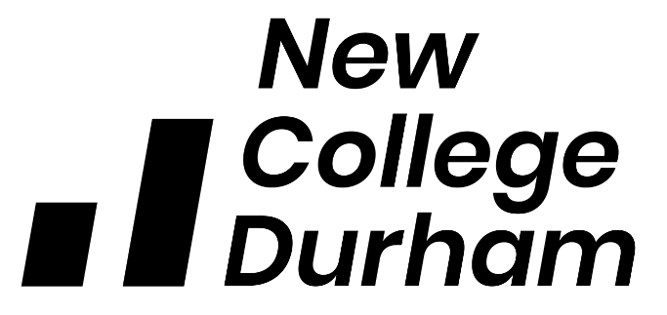

HE COMMUNICATIONS AGREEMENT

Introduction

A rapidly changing environment within higher education and recent feedback from NCD students has identified some dissatisfaction with communication stating there is times when communications are not clear or consistent across programme areas. While we acknowledge student communication can be a complex issue, involving a number of different interactions at various levels of the College. This document serves as a set of guidelines to inform both staff and students of the College HE communication channels, ensuring all HE students receive the most effective experience.

This Agreement aims to identify
- how communication between staff and HE students is to be conducted,
- identifying the channels of communication.
- the responsibility of the staff and the wider College community
- the responsibility of the students

The agreement will act as a guide for staff and students recognising that there are significant mutual benefits to be gained from such an agreement and therefore provide a framework which removes many of the key factors that cause students to report dissatisfaction with the College’s communications.

Period of the Agreement

The document is limited in scope currently to support the current pandemic, with the intention to review and revise as a permanent communication strategy once wider consultation can be agreed.
Hours of Operation & Communication response timelines
Assistance will normally be available from 8:30 AM to 5:00 PM, Monday through to Friday, except when the College is closed due to holidays, weekends or administrative closure.
Staff should endeavour to respond to student queries as soon as reasonably possible. It is however acknowledged that with staff working from home during the current lockdown, as well as delivering remote teaching that there may be delays in responses being given. Staff should ensure that an autoreply is added to their email detailing periods where they are not available and where possible provide an alternative contact for the student to redirect their query to.

Where there may be a delay in responding to a student, due to nature of the query, staff should acknowledge receipt of the email and detail their actions.

Email Communications

During this period of uncertainty email will be the primary source of communications for HE students. All students have a College email account and staff should, wherever possible use the student College email address to engage in all correspondence.
Communication and interaction agreement
Together we will:
- Communicate with openness, respect and honesty, illustrated through transparency and constructive dialogue.

As a student I will:
- Keep up to date with my programme’s primary channels of communication as identified by my tutor and respond in a timely manner when required.
- Engage in feedback mechanisms that seek to evaluate my learning experience.
- Express any concerns I have regarding my studies in the first instance to my tutor.
- Inform the College if messages or information is not reaching me in a satisfactory manner by proactively participating in feedback opportunities.
- Express their views to their student representatives or Students’ Union president via the following email: student.union@newdur.ac.uk so that they can represent them effectively. (Also please see Guide to Student Union).

Academic Staff will:
- Provide you with the information and support to help you plan your studies,
- Use appropriate technology to teach, support and communicate with you to enhance your learning experience.
- Provide you with full, accurate and accessible information regarding your programme of study, its regulations and support opportunities.
- Work in partnership across the College to set and deliver consistent levels of service for you.
- Demonstrate high professional standards when interacting with you.
- Listen and respond to any concerns regarding your learning experience in a timely manner.
- Ensure student queries are responded to in a reasonable timeframe and where any delay may be necessary to detail the reasons why and the actions taken to provide a response .
- Deliver professionalism in all communications, ensuring they serve the best interests of the College and its students at all times

The Higher Education & Development Quality Unit (HEDQU) will:

- Work in partnership across the Curriculum schools to set and deliver consistent levels of service for you.
- Respond in a fair, timely and transparent manner to academic complaints and appeals (See Guide to Academic Appeals)
- Respond in a fair, timely and transparent manner to complaints and compliments (see Student Complaints and Compliments Procedure)

The College will:

- Respond in a fair, timely and transparent manner to complaints and compliments (see Student Complaints and Compliments Procedure)

