The Higher Education Hardship Fund is available to provide help to those students with genuine financial needs relating to their course of study. To be eligible for consideration for the Hardship Scheme the student must satisfy all the following criteria:
- Applied for their full entitlement of student loan/relevant bursary and received their first instalment – evidence must be provided.
- Have a gross household income of less than £32,000 in the previous tax year 2025/26 – evidence must be provided.
- Attendance of at least 90% (set at 90% acknowledging that students may not be able to achieve 100% attendance) and be up to date with all course work/assignments/placements and receive a satisfactory tutor report.
Students must satisfy the three following residential requirements relating to their residence and immigration status on the first day of the first academic year of the course, they must be:
- A resident in the United Kingdom and Islands throughout the three-year period preceding that date other than wholly or mainly for the purpose of receiving full-time education; (Students covered by the Bidar Guidance and those classed as “home” students are also eligible).
- A resident in England, Wales, Scotland, or Northern Ireland (Students from the Channel Islands and the Isle of Man are ineligible for support).
- Settled in the United Kingdom under the terms of the Immigration Act 1971, in other words ordinarily resident here without being subject to any restriction on the period for which they may stay.
Applications for support from the Higher Education Hardship Fund can be made by ‘home students’ undertaking the following full-time courses at undergraduate level:
- First Degree, such as BA, BSc, or BEd
- Diploma of Higher Education (DipHE)
- Higher National Diploma (HND)
- Higher National Certificate (HNC)
- Certificate of Higher Education (CertEd)
- NVQ at level 4 where this is awarded alongside a First Degree, DipHE or HND
- Foundation Degree
- Course for the initial training of teachers
- Course which prepares for a professional examination of a higher standard than GCE advanced level, Scottish Higher, National Certificate or National Diploma

Part-Time Undergraduates
Applications for support can be made by ‘home students’ on part-time HE courses who are studying at least 50 per cent (60 credits) of a full-time equivalent course. Any students whose disability (including physical and mental health) prevents them from studying at least 50 per cent of a full-time course may be eligible for a payment from the Fund provided they are studying for at least 25 per cent (30 credits) of a full-time equivalent course at undergraduate level.
Students on foundation years, which are an integral part of one of the above courses and where progression to the HE part of the course depends on the completion of the foundation year, are also eligible to apply for help from the Fund. Students on foundation or access courses that are FE equivalent (e.g., Art and Design) should apply to the FE Learner Support Fund.
Childcare support
As part of the HE Hardship und students may also be eligible for a contribution of costs towards childcare, this is not paid direct to the provider but to the student and will be made as part of the bursary payment. If this is something you would like considered complete required information on page 3.

Applications
Applications will only be considered for the period in which the application is received. Applications received after the deadline date will not be accepted but will be considered for the next payment where applicable.
 | Application Deadline | Payment Date
Term 1 | Thursday 8th October 2026 | Friday 6th November 2026
Term 2 | Thursday 11th February 2027 | Friday 5th March 2027
Term 3 | Thursday 6th May 2027 | Friday 4th June 2027
If your form is incomplete, it may be returned to you and your application will be delayed. Failure to provide evidence to accompany this form would result in the application not being processed.
You agree to notify the Bursary Support Fund Office of any change in your circumstances which may affect your eligibility for support, or of any change to your course.
You understand that if you are in receipt of any benefits, you must declare that you are receiving financial support from the college to any external agencies.

Payments
The Bursary Support Fund Team will determine whether a payment will be made based on attendance of at least 90%, be up to date with all course work/assignments and receive a satisfactory tutor report.
Payments will be made.
- Direct to the student via BACS.
- Subject to the student meeting the above eligibility criteria, receipt of a completed form and evidence of household Income, including all benefits – income must be below £32,000 to receive financial support.
- Depending on available funds (the fund is a finite resource, and the available funds will be distributed according to financial circumstances and need).
- On a pro rata basis based upon the number of study hours.
- On the following criteria.
Tier 1 Hardship | Tier 2 Hardship | Tier 3 Hardship
Annual household income is £16,190 gross per annum or less. | Annual household income is greater than £16,191 and less than or equal to £25,999 gross per annum or less. | Annual household income is greater than £26,000 but less than or equal to £32,000.
Please note no retrospective payments will be made.
For further information, please refer to the Higher Education Hardship Fund Policy 2026/27, copies of which are available on the College website or contact the Bursary Support Fund Team
The data you have provided on this form will be used to process your application and we will hold it in our systems until 6 years after you finish your course to ensure we have adequate records to deal with enquiries and complaints. We will decide based on your household income and the data you provide will not be passed to any other third party without your consent, except when the College is required to do so by law. For further information on how the College manages your information please see the Privacy Notices page on our website.

Complete this form fully and ensure that the form is signed.
Student Reference Number |  |  |  |  | Date of Birth
First name: |  |  |  | Surname
Are you a returning student? |  |  | Yes/No | Are you a new student? |  |  |  | Yes/No
House number |  |  |  | Street
Town |  |  |  | Postcode
Contact number |  |  |  | Email address
Course |  |  |  | Course Tutor
Have you applied for Student Finance England Support? |  |  |  |  | Yes/No (this is a requirement to apply for this bursary)
Is this your first degree? |  |  |  |  | Yes/No
Are you studying? |  | Full/Part-time |  |  |  | If part-time, please state how many hours per week do you study?

Please state how you would use hardship funding to ensure that you are able to engage in your studies?

Residential Status
Have you been a resident in the UK/EEA for the last 3 years? | Yes/No

Are you an unaccompanied Asylum Seeker? (If yes, state your country of origin and date of entry to the UK) | Yes/No | If yes, country of origin | Date of Entry to UK
Student Bank Details
Name on account: |  |  |  |  |  |  | Bank Name:
Sort Code: |  |  |  |  |  |  |  | Account No:
Details of Child(ren) receiving childcare for which you would like support for
Provider Name: |  |  |  | Ofsted Registration No:
Address |  |  |  |  |  |  | Postcode
Name of contact/position and email address |  |  |  |  |  | Telephone No
Full Name(s) of Child(ren) |  |  |  |  | Date of Birth
Full Name(s) of Child(ren) |  |  |  |  | Date of Birth

Required Evidence: You must have applied for full entitlement of student loan/relevant bursary and received the first instalment – evidence must be provided from the following

Student Finance England | Mandatory evidence from Student Finance England
NHS, Podiatry and Social Worker Bursary (if applicable) | Mandatory evidence from the provider

Household income
Example of evidence to be handed in with Application Form
Universal Credit – if households receive any element of this ensure this is the primary evidence submitted. | Please download the last three consecutive monthly statements that clearly show the claimant's name, address, and the sections detailing entitlements and deductions. All Pages, see below example 1.  Example 1  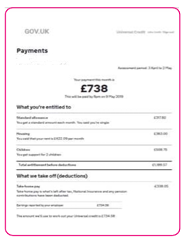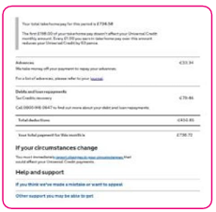  To do this  - Log into your UC account and go to Payment screen  - Select the month you wish to view  - Click – Print This Statement  - Once you click Print This Statement, a window will pop up  - Use the Download Buttonand select a location for the download to be sent  The statement will then save as a PDF document which you can then attach to an email  If you cannot navigate this please take screen shots and save as photos which you can then attach to an email  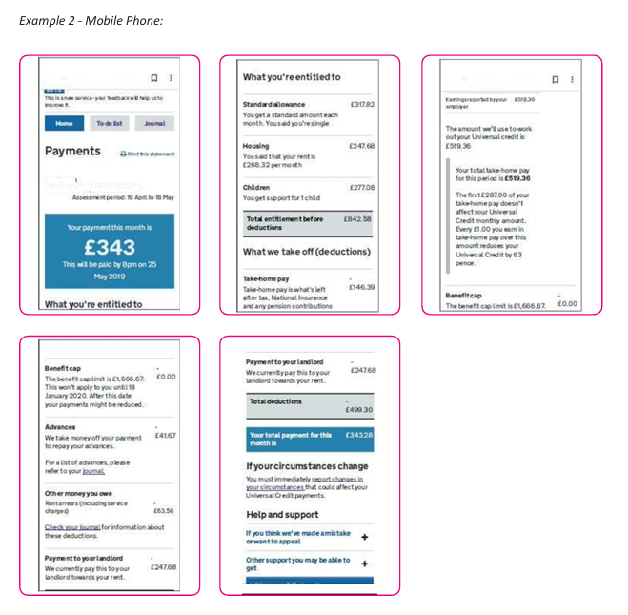

If the household does not receive any Universal Credit the following evidence will be accepted.
Submit all of the following evidence which applies.

Job Seekers Allowance |  | Latest Award letter, no more 12 months old. All Pages
Income related Employment and Support Allowance |  | Latest Award letter, no more 12 months old. All Pages
Support under part VI of the immigration and Asylum Act 1999 |  | Evidence of provided support
Guaranteed element of Pension Credit |  | Latest award letter, no more than 12 months old All Pages
Salary - Employed | Provide a copy of your P60 dated April 26 or last consecutive 3 months' pay slips.
Self-Employed | Latest documentation from Accountant or Self -Assessment showing gross earnings
Pension | Provide the latest pension statement/P60.

Please note that if you live with parents or a partner, their income and any benefits they receive will be included in the assessment. If you live independently, we will need evidence of your income and any benefits you receive. For this application, "household income" is defined as the total gross taxable income for the entire household, including taxable benefits.

Student Declaration
By signing this form, you agree to the terms and conditions of the High Education Bursary Support Fund Policy 2026/27. The information you have given is correct, true, and accurate and understand that if false, incomplete, misleading or inaccurate information is provided you may have to repay any award, your application will be disqualified, and this could result in action under the student disciplinary procedure. If you withdraw from your course early or where you are subject to disciplinary sanctions, consideration will be made regarding continued eligibility to receive support. You are aware that financial assistance is dependent upon satisfactory attendance (90%), behaviour and all work being up to date.

Student Signature: ______________________________ Date: ________________

For further guidance/assistance, please contact the Bursary Support Fund Team
0191 375 4218 | Email: Bursarysupportfund@newdur.ac.uk | Office: East Mall - Orange 0.28

Bursary Support Fund Office use only
Date assessed | Household income | SFE | Grants | Total

The data you have provided on this form will be used to process your application and we will hold it in our systems until 6 years after you finish your course to ensure we have adequate records to deal with enquiries and complaints. We will decide based on your household income and the data you provide will not be passed to any other third party without your consent, except when the College is required to do so by law. For further on how the College manages your information please see the Privacy Notices page on our website.

